April 7, 2022

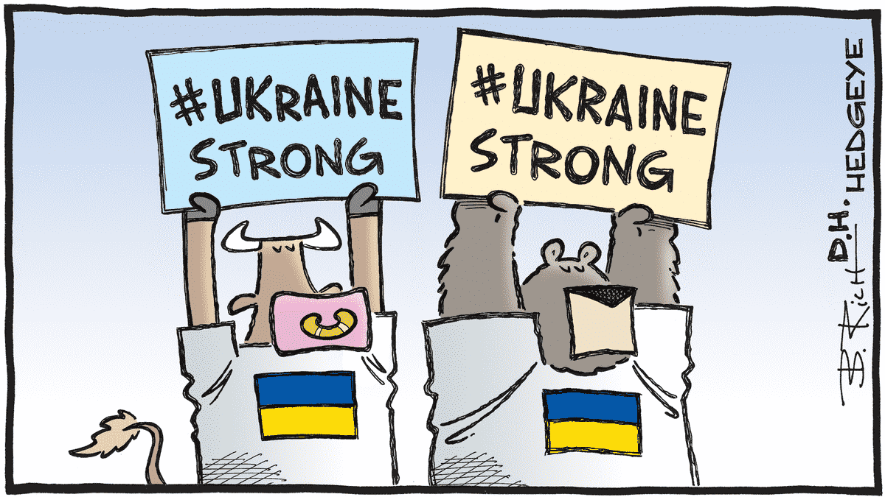
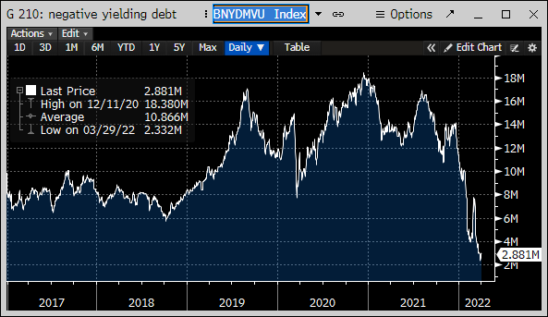
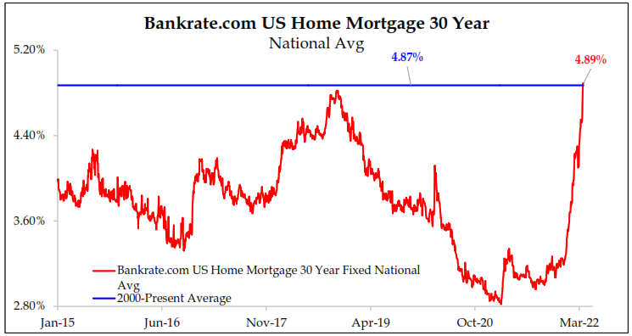
Where to begin? First, as always, I hope this letter finds you safe and healthy. I know we sometimes take that for granted, particularly in the US, but it seems particularly relevant to ask given the humanitarian crisis unfolding overseas with the war in Ukraine. We will touch on the financial market implications of these events later, but for now our thoughts and prayers are with the brave people of Ukraine in their struggle against Putin and his armies. Those of you that have read my letters before or heard me speak about the economy and markets know that one of my favorite quotes is by the late Economics professor from MIT, Rudy Dornbusch. He famously said, “In economics, things take longer to happen than you thought they would and then they happen faster than you thought they could.” The two charts on this page epitomize this saying. The first is the amount outstanding of negative yielding debt around the world (in trillions). These mostly reside in Europe and we have talked for years about why anyone would buy a negative yielding bond (literally you are guaranteeing a negative return on your money), yet they continued to grow, reaching a peak of over $18 trillion in late 2020. Then suddenly, the amount outstanding in these instruments are down 75% in just three months as interest rates around the world move higher in response to inflation. A second chart to the left is related to this same dynamic but hits much closer to home (pun intended). This chart shows the average 30-year mortgage rate. While you can see we are actually just back to the 20-year average (blue line) on this metric, the story is the speed with which we have risen from a 3.25% rate at the end of 2021 (“…faster than you thought they could.”) So what’s the point? Well, it’s the multifaceted impact that inflation is having on various asset and debt markets around the world and the pace with which policy makers are being forced to respond and financial markets are repricing for these changes.

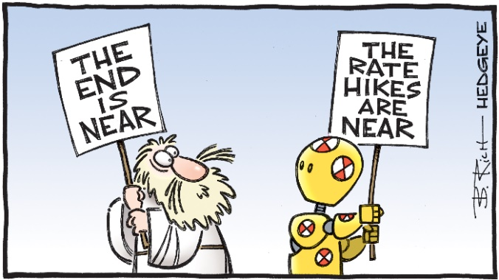
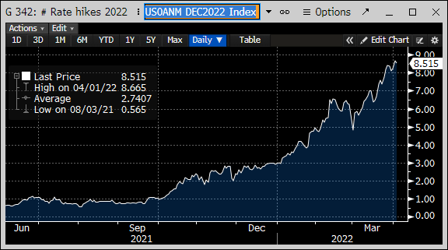
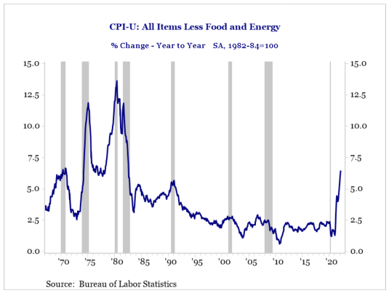
The Federal Reserve is a case in point on this front. Both John McAlhany and John Wiseman talk about the shift in Federal Reserve policy in our Market Commentary accompanying this letter. However, the visual on the following page really brings home the shift in policy that has occurred over the past six months. This chart shows the number of rate hikes from the Fed the market expects in 2022. At the end of September 2021 there was one hike priced in, by December 2021 it was three and now we have over eight. Expectations have more than doubled over the past three months. Given this additional information, the 30-year mortgage chart on the prior page makes more sense. And what is the Fed responding to? Inflation at levels last seen in the early 1980’s (see chart below). For context, the Fed Funds Rate was at 10% then vs. 0.5% upper bound now. Needless to say the Fed is a bit behind the curve here. Ok, so the Fed will be tightening monetary policy by raising rates or shrinking the balance sheet or some combination of the two. All else being equal, this will lead to tighter financial conditions. Something we are already starting to see as the yield curve flattens (i.e. similar rates for short and long bonds).

In fact, when we look at certain points along the Treasury yield curve you see what we call an inversion, that is higher rates for shorter maturities vs. longer ones. For example, the 3-year Treasury yield is 2.61% vs. the 10-year at 2.42%. This is not “normal” and indicates a tepid outlook for future growth. There has been a lot written recently about the inversion between 2-year and 10-year rates, specifically, as this condition has previously signaled a recession with a 12 to 18-month lead time. While not a guarantee of this outcome, we take this signal seriously and are watching to see how long the inversion lasts and how deep it goes as both of these can be factors in its predictive efficacy. Moreover, stocks can still appreciate even after this occurs, with 1998 to 2000 and 2006 to 2007 as examples, but it does put you potentially on the clock.

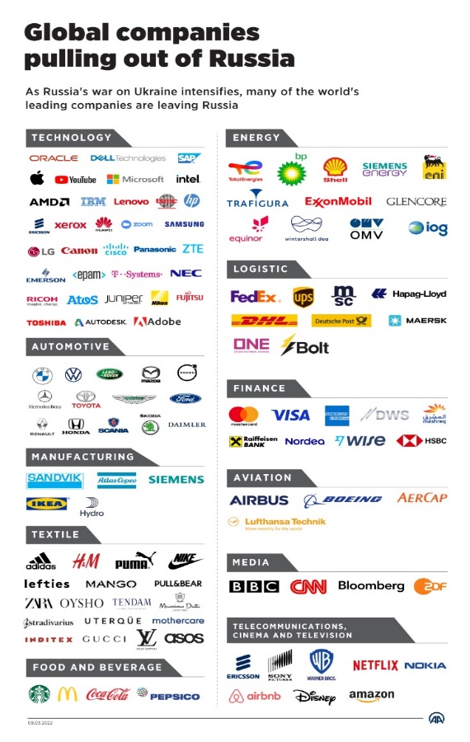
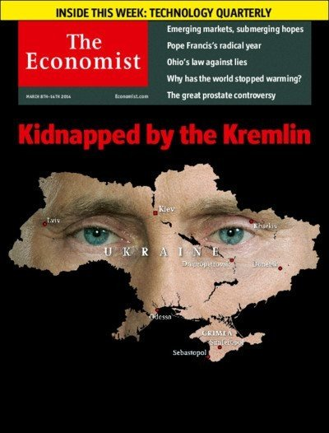
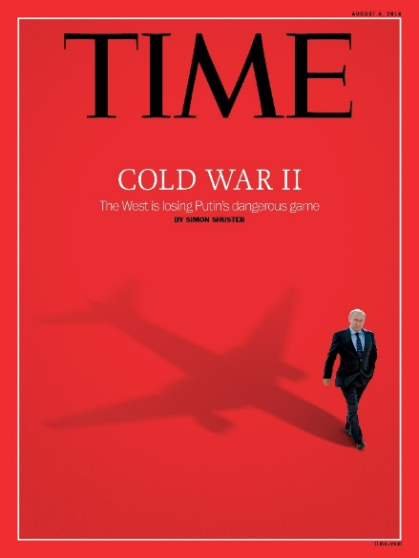
Keep in mind that the shift in the Fed policy stance and problems with inflation were all evident before the invasion of Ukraine started and commodity prices went parabolic. This complicates the Fed’s job as it cannot influence the supply of crude oil or nickel, only the demand for these goods. Sadly, when it comes to Ukraine, we have seen these events play out before. The two magazine covers to the right are not from 2022 but 2014. Even if the actions taken by Putin were predictable, the global response to them is completely different than anything we have seen before. The US and other allies have frozen assets outside of Russia, essentially weaponizing the financial system and the US dollar to try and cripple Russia’s economy. In addition, we have seen dozens of companies pull out of Russia or cease to do business with them (see list to left). Most financial markets index providers are removing Russian exposure from their benchmarks. The sanctions and other steps taken against Putin and his regime are the equivalent of dropping a financial nuclear bomb on the Russian economy. Will it matter? Only time will tell, but as we wait, there are significant short-term and long-term implications from these events.

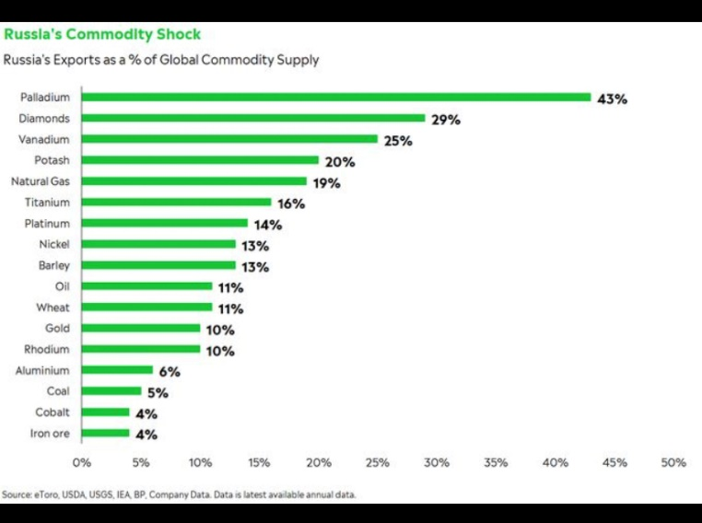
In the near term, the table to the right outlines the many commodity markets in which Russia plays a significant role (i.e. it’s not just oil). In addition to these, Ukraine accounts for 8% of global wheat exports, putting further pressure on global food prices. Energy supplies are impacted globally, but much more acutely for countries in Europe. It has been well documented that Germany, for instance, gets 50% of its energy supplies from Russia. This will no longer be tolerated given the events unfolding, yet it cannot be rectified overnight. The national security implications of energy security are becoming painfully obvious to Germany and Europe as a whole. I do not believe this will go back to the way it was, even if the war ended tomorrow.

The longer-term implications of these events may not be as obvious but are no less impactful to our world. Since the fall of the Berlin Wall in 1989, we have referred to events that have occurred as the “post-Cold War period.” I believe the invasion of Ukraine by Russia and the global response make the use of this term obsolete and we are unfortunately entering a period that once again will be defined by West (US and Europe) vs. East (Russia and China). The globalization of world economies that began during the prior period will likely give way to a focus back on regional alliances and supply chains and potentially put an end to the pursuit of the low-cost producer in exchange for the secure producer of goods. The good news regarding this dynamic is the opportunity for more reshoring of jobs back to the US and the build-out of more local and regional supply chain networks. However, we have to find and train the workers to be able to take advantage of these opportunities. Intel building new semiconductor factories in the US is an example of this transformation in progress.

We are fortunate in the US to have abundant natural resources, a growing population, the reserve currency of the world and some of the best technology and companies in our own backyard, and we need to have the right policies in place to get the most out of these advantages. I know that I have outlined many headwinds and concerns in this letter, but keep in mind that opportunities emerge from these types of tumultuous times. We are searching for these each and every day.

Moving on from markets to company news, we have lots to share this quarter. First, we want to welcome Drew Pile to the family. Drew belongs to our own Quintin Pile and his wife Molly and was born on the very special date of 2/22/22 (and therefore will affectionately be known internally at Greenwood Capital as “Deuce”). Congratulations to Quintin and Molly.

Second, we want to take a moment to recognize our own Dr. John McAlhany. John tried to retire back in 2006, but we were not ready to let him go and he graciously agreed to stay on as a consultant to our Investment Committee since that time. We and our clients have been the beneficiaries of his wit and wisdom over many years with his Economic Overviews in our Market Commentaries published each quarter, the last of which is included after this letter. Alas, John is officially retiring and to paraphrase General Douglas MacArthur, old economists never die, they just fade away. Thank you John for all that you have done for Greenwood Capital and its clients over the years. We would truly not be where we are today without you. We will be celebrating John’s career with an event in Greenwood, hopefully in May and we will send those details out as soon as we have them available.

Finally, we want to welcome a new member to our investment team, Dr. Mark Pyles. Mark, a Professor of Finance at the College of Charleston, is joining Greenwood Capital as a consultant and will be a member of our Investment Committee. Mark received an M.S. in Economics and a Ph.D. in Finance from the University of Kentucky and has been teaching at the College of Charleston since 2005. We are excited to have Mark’s expertise at the table.

On behalf of all the employees at Greenwood Capital,
Sincerely,
The information contained within has been obtained from sources believed to be reliable but cannot be guaranteed for accuracy. The opinions expressed are subject to change from time to time and do not constitute a recommendation to purchase or sell any security nor to engage in any particular investment strategy. Investment Advisory Services are offered through Greenwood Capital Associates, LLC, an SEC-registered investment advisor.
Walter B. Todd, III, President & Chief Investment Officer

